https://newyork.cbslocal.com/2019/09/23/ballet-hispanico-hispanic-heritage-month/

Ballet Hispanico Lets Performers Share Culture, Heritage Through Dance
NEW YORK (CBSNewYork) — Music, dance and art are all forms of expression, but they’re also ways to express and explore a culture.
Ballet Hispanico is one of the largest ballet studios in America, spreading stories of Latinx culture and heritage through dance.

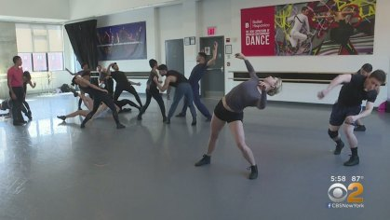
(Credit: CBS2)
“When you’re in an artistic space, you are learning a new way to communicate,” CEO Eduardo Vilaro said. “We see a lot of things that are in us that we share that are alike much more quickly than we do when we are sharing language.”
At Ballet Hispanico, the dancers are also sharing their heritage, CBS2’s Jessica Layton reports.
The dance company started 50 years ago to give contemporary Hispanic culture a place in American society. They suffered a flood three years ago at their West 89th Street offices but bounced back.
Web Extra: Ballet Hispanico CEO & Artistic Director On CBSN New York
The dancers perform for millions across the world — and more locally, at the Apollo Theater.
“A lot of them become excellent educators because we’re out in the community working with them and they work with me, so I think the reaction of the dancers is always, wow, I thought I’d just be a dancer but I’m so much more,” Vilaro said.
(Credit: CBS2)
Many of the dancers say they’re constantly learning something new about their own culture at the studio. For example, different body movements can represent rituals or even show signs of fertility and love.
“All dance and all art represent the culture in which it was created,” dancer Paulo Hernandez-Farella said. “It’s so nice to learn what’s behind that and be able to express that through dance now … and say that this is so much more than entertainment, it’s actually someone’s culture, it’s actually my culture and that’s why it’s important to me.”
Ballet Hispanico ultimately aims to give its dancers a voice and access to the arts during Hispanic Heritage Month and every day all year.
This Sunday, the ballet is hosting a block party right outside its Upper West Side studio. There will be music, performances and dancing lessons. For more information and to register, visit ballethispanico.org.

